Q2:

Query the **NAME** field for all American cities in the **CITY** table with populations larger than 120000. The CountryCode for America is USA.

The **CITY** table is described as follows:  
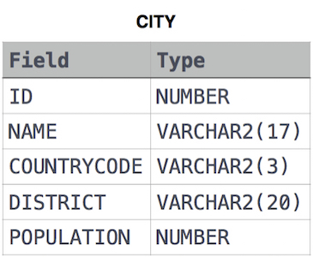

**Solve:**

**SELECT NAME**

**FROM CITY**

**WHERE COUNTRYCODE = "USA" AND POPULATION > 120000**